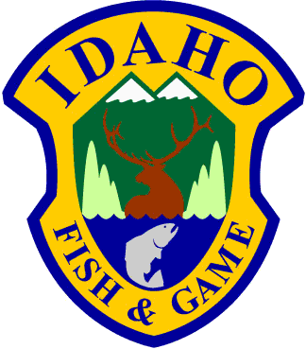**Idaho Department of Fish and Game**

600 S Walnut / P.O. Box 25 C.L. "Butch" Otter / Governor

Boise, Idaho 83707 Virgil Moore / Director

February 13, 2013

Kenneth Cole

Western Watersheds Project

PO Box 2863

Boise, ID 83701

[ken@westernwatersheds.org](mailto:ken@westernwatersheds.org)

Dear Mr. Cole:

Please find enclosed a copy of 2 Excel spreadsheets responsive to your public records request dated January 30, 2013 related to non-target species caught by wolf trappers.

I am providing summarized data from 2 sources of information.

The first summary is taken from furtaker report cards required to be submitted by licensed trappers at the end of the trapping season. For the trapping season year ending June 30, 2012, we received reports from 154 trappers who indicated that they trapped for wolves. Forty-one of those trappers reported a total of 99 nontarget catches. Fifty of those were released alive. I have attached a summary of those nontarget catches by species as reported by the trappers. Please note that, because of the way this information was collected on the fur-taker report card, we have no way of determining from these reports which or how many of the reported nontarget animals were caught in traps set for wolves vs. traps set by for other species. For example, 2 wolves were reported taken as nontargets and released alive.

The second summary is taken from response to a survey we conducted of 460 individuals who purchased a trapping license for the 2011-2012 trapping season and also had attended a wolf trapper education class. One hundred forty-three (143) of the 339 respondents indicated they trapped for wolves during the season and reported 147 nontarget captures, 66 of which were released alive (see Table next page).

While trapping for wolves, did you trap any of the following species?

If yes, how many of each species did you catch? Please indicate if they were released alive or if they died.

| Species Caught | # Caught | # Released Alive | # Dead |
| --- | --- | --- | --- |
| White-tailed deer | 45 | 33 | 12 |
| Mule deer | 2 | 2 | 0 |
| Elk | 18 | 11 | 1 |
| Moose | 4 | 4 | 0 |
| Mountain lion | 9 | 3 | 6 |
| Black bear | 0 | 0 | 0 |
| Lynx | 0 | 0 | 0 |
| Bobcat | 9 | 4 | 5 |
| Domestic pets | 9 | 7 | 2 |
| Coyote | 45 | 1 | 38 |
| Fisher | 1 | 1 | 0 |
| Goose | 1 | 0 | 1 |
| Skunk | 2 | 0 | 2 |
| Raccoon | 1 | 0 | 1 |
| Raven | 1 | 0 | 1 |
| Total | 147 | 66 | 69 |

Information responsive to your requests could be compiled with relatively little personnel time and involved fewer than 100 pages of records. As a result, there is no fee associated with these requests under Idaho Code Section 9-338(8). Please let me know if you have questions about this information.

Sincerely,



Jon Rachael

State Wildlife Manager

cc: Kathleen Trever, Mary Boyer